Program

23.10.2010. godine ~ Banski dvor
18h
Simply wear
Roma
Fashion

19h
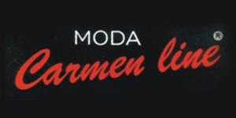 Plamenka Stojić~BiH
Zoran Mrvoš~Hrvatska

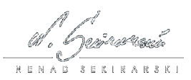Nenad Sekirarski~Makedonija

20h
Slovenija
- 

24.10.2010. godine ~ Banski dvor

17h
~Italija
~Srbija

24.10.2010. godine
18h Fashion day 2010

wedding
~Saloni vjenčanica Fortuna~Banja Luka
- Pronovias,
- San Patrick,
- Demetrios,
- Eddy K,
- Mori Lee...

~ Jelena shop
~Vjencanja Extreme~Banja Luka
- Ronald Joyce
- Maria Karin
- Madelin Gardner~New York
- Victoria Jane

~Biciani & MQV Paris

~classic

~Studio Hera~Banja Luka
- La Sposa
- Meggie
- Sottero

20h

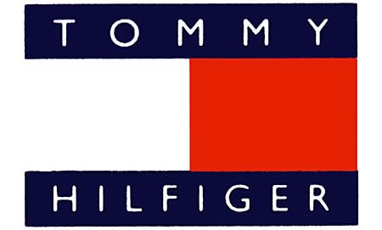

inside out
City time 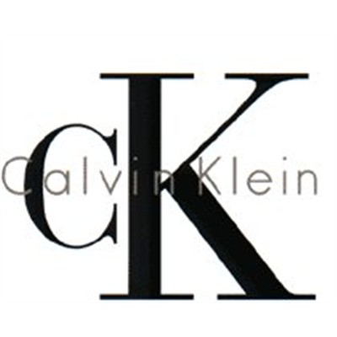
and Kosta Miljkovic


